LAB 10 REPORT

NAME: FONG WEI TZE

STUDENT ID: 22030274

**PART A: Packet Tracer - Verify IPv4 and IPv6 Addressing**

|  |  |  |  |  |
| --- | --- | --- | --- | --- |
| **Device** | **Interface** | **IP Address/Prefix** | | **Default Gateway** |
| **R1** | **G0/0** | **10.10.1.97** | **255.255.255.224** | **N/A** |
| **2001:db8:1:1::1/64** | |
| **S0/0/1** | **10.10.1.6 255.255.255.252** | | **N/A** |
| **2001:db8:1:2::2/64** | |
| **Fe80::1** | |
| **R2** | **S0/0/0** | **10.10.1.5** | **255.255.255.252** | **N/A** |
| **2001:db8:1:2::1/64** | |
| **S0/0/1** | **10.10.1.9** | **255.255.255.252** | **N/A** |
| **2001:db8:1:3::1/64** | |
| **Fe80::2** | |
| **R3** | **G0/0** | **10.10.1.17 255.255.255.240** | | **N/A** |
| **2001:db8:1:4::1/64** | |
| **S0/0/1** | **10.10.1.10** | **255.255.255.252** |
| **2001:db8:1:3::2/64** | |
| **Fe80::3** | |
| **PC1** | **NIC** | **10.10.1.100 255.255.255.224** | | **10.10.1.97** |
| **2001:db8:1:1::a/64** | | **Fe80::1** |
| **PC2** | **NIC** | **10.10.1.20** | **255.255.255.240** | **10.10.1.17** |
| **2001:db8:1:4::a/64** | | **Fe80::3** |

**Part 2: Test Connectivity Using Ping**

**Step 1: Use ping to verify IPv4 connectivity.**

1. From **PC1**, ping the IPv4 address for **PC2**.

Question:

Was the result successful?

The ping was successful.

From **PC2**, ping the IPv4 address for **PC1**.

Was the result successful?

The ping was successful.

**Step 2: Use ping to verify IPv6 connectivity.**

From **PC1**, ping the IPv6 address for **PC2**.

**Was the result successful?**

**The ping was successful.**

From **PC2**, ping the IPv6 address of **PC1**.

**Part 3: Discover the Path by Tracing the Route**

**Step 1: Use tracert to discover the IPv4 path.**

1. From **PC1**, trace the route to **PC2**.

PC> **tracert 10.10.1.20**

Questions:

What addresses were encountered along the path?

10.10.1.97, 10.10.1.5, 10.10.1.10, 10.10.1.20

***Type your answers here.***

With which interfaces are the four addresses associated?

10.10.1.97 is associated with G0/0 of R1.

10.10.1.5 is associated with S0/0/0 of R2.

10.10.1.10 is associated with S0/0/1 of R3.

10.10.1.20 is associated with NIC of PC2

***Type your answers here.***

1. From **PC2**, trace the route to **PC1**.

What addresses were encountered along the path?

10.10.1.17, 10.10.1.9, 10.10.1.6, 10.10.1.100

***Type your answers here.***

With which interfaces are the four addresses associated?

10.10.1.17 is associated with G0/0 of R3.

10.10.1.9 is associated with S0/0/1 of R2.

10.10.1.6 is associated with S0/0/1 of R1.

10.10.1.100 is associated with NIC of PC1.

**Step 2: Use tracert to discover the IPv6 path.**

1. From **PC1**, trace the route to the IPv6 address for **PC2**.

PC> **tracert 2001:db8:1:4::a**

Questions:

What addresses were encountered along the path?

2001:DB8:1:1::1, 2001:DB8:1:2::1, 2001:DB8:1:3::2, 2001:DB8:1:4::A

***Type your answers here.***

With which interfaces are the four addresses associated?

2001:db8:1:1::1 is associated with G0/0 interface of R1.

2001:DB8:1:2::1 is associated with S0/0/0 interface of R2.

2001:DB8:1:3::2 is associated with S0/0/1 interface of R3.

2001:DB8:1:4::A is associated with NIC interface of PC2.

***Type your answers here.***

1. From **PC2**, trace the route to the IPv6 address for **PC1**.

Questions:

What addresses were encountered along the path?

2001:DB8:1:4::1, 2001:DB8:1:3::1, 2001:DB8:1:2::2, 2001:DB8:1:1::A***ype your answers here.***

With which interfaces are the four addresses associated?

2001:DB8:1:4::1 is associated with G0/0 of R3.

2001:DB8:1:3::1 is associated with S0/0/1 of R2.

2001:DB8:1:2::2 is associated with S0/0/1 of R1.

2001:DB8:1:1::A is associated with NIC of PC1.

**PART B: Packet Tracer - Use Ping and Traceroute to Test Network Connectivity**

|  |  |  |  |  |
| --- | --- | --- | --- | --- |
| **Device** | **Interface** | **IP Address/Prefix** | | **Default Gateway** |
| **R1** | **G0/0** | **2001:db8:1:1::1/64** | **255.255.255.224** | **N/A** |
| **G0/1** | **10.10.1.97** | **255.255.255.224** |
| **S0/0/1** | **10.10.1.6** |  |
| **2001:db8:1:2::2/64** | |
| **Fe80::1** | |
| **R2** | **S0/0/0** | **10.10.1.5** | **255.255.255.252** | **N/A** |
| **2001:db8:1:2::1/64** | |
| **S0/0/1** | **10.10.1.9** | **255.255.255.252** |
| **2001:db8:1:3::1/64** | |
| **Fe80::2** | |
| **R3** | **G0/0** | **2001:db8:1:4::1/64** |  | **N/A** |
| **G0/1** | **10.10.1.17** | **255.255.255.240** |
| **S0/0/1** | **10.10.1.10** | **255.255.255.252** |
| **2001:db8:1:3::2/64** | |
| **Fe80::3** | |
| **PC1** | **NIC** | **10.10.1.98** | **255.255.255.224** | **10.10.1.97** |
| **PC2** | **NIC** | **2001:db8:1:1::2** | | **Fe80::1** |
| **PC3** | **NIC** | **10.10.1.18 255.255.255.240** | | **10.10.1.17** |
| **PC4** | **NIC** | **2001:db8:1:4::2** | | **Fe80::2** |

**Part 1: Test and Restore IPv4 Connectivity**

**Step 1: Use ipconfig and ping to verify connectivity.**

**Step 2: Locate the source of connectivity failure.**

1. From **PC1**, enter the necessary command to trace the route to **PC3**.

Question:

What is the last successful IPv4 address that was reached?

10.10.1.97

1. From **PC3**, enter the necessary command to trace the route to **PC1**.

Question:

What is the last successful IPv4 address that was reached?

10.10.1.17

1. Enter the **show ip interface brief** command to list the interfaces and their status. There are two IPv4 addresses on the router. One should have been recorded in Step 2a.

Question:

What is the other?

10.10.1.6

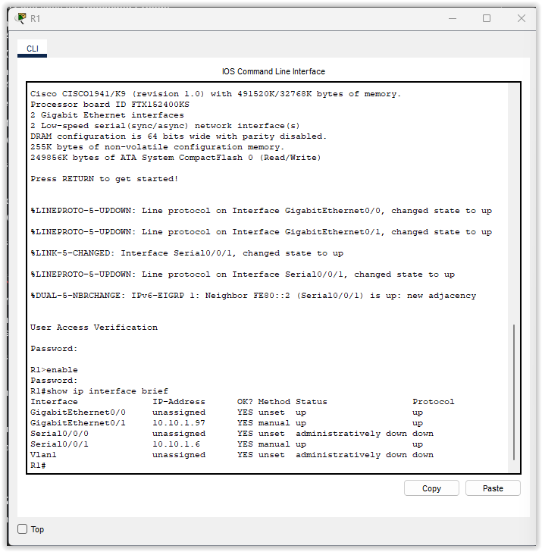

1. Enter the **show ip route** command to list the networks to which the router is connected. Note that there are two networks connected to the **Serial0/0/1** interface.

Question:

What are they?

10.10.1.4/30 and 10.10.6/32

1. Repeat steps 2c through 2d with **R3** and record your answers.

1. Enter the **show ip interface brief** command for R2 and record your addresses.

The addresses are 10.10.1.2 and 10.10.1.9.

**Step 3: Propose a solution to solve the problem.**

Compare your answers in Step 2 to the documentation you have available for the network.

Question:

**What is the error?**

R2’s S0/0/0 interface is configured with the wrong IP address.

***Type your answers here.***

**What solution would you propose to correct the problem?**

Assign the correct IP address for R2 S0/0/0 interface which is 10.10.1.5.

**Step 5: Verify that connectivity is restored.**

1. From **PC1** test connectivity to **PC3**.
2. From **PC3** test connectivity to **PC1**.

Question:

Is the problem resolved?

Yes, the problem is resolved.

**Part 2: Test and Restore IPv6 Connectivity**

**Step 1: Use ipv6config and ping to verify connectivity.**

**Step 2: Locate the source of connectivity failure.**

1. **From PC2, enter the necessary command to trace the route to PC4.**

**Question:**

**What is the last successful IPv6 address that was reached?**

**2001:DB8:1:3::2**

1. **From PC4, enter the necessary command to trace the route to PC2.**

**Question:**

**What is the last successful IPv6 address that was reached?**

There is no successful IPv6 address that was reached.

1. **Enter the show ipv6 interface brief command to list the interfaces and their status. There are two IPv6 addresses on the router. One should match the gateway address recorded in Step 1d.**

**Question:**

**Is there a discrepancy?**

Yes.

**Step 3: Propose a solution to solve the problem.**

1. **Compare your answers in Step 2 to the documentation you have available for the network.**

**Question:**

**What is the error?**

***T***  PC4 is using the wrong default gateway configuration.

***ype your answers here.***

**What solution would you propose to correct the problem?**

Assign the correct default gateway for IPv4 which is FE80::3.

**Step 5: Verify that connectivity is restored.**

1. From **PC2** test connectivity to **PC4**.
2. From **PC4** test connectivity to **PC2**.

Question:

Is the problem resolved?

Yes.

**PART C: Packet Tracer - Use ICMP to Test and Correct Network Connectivity**

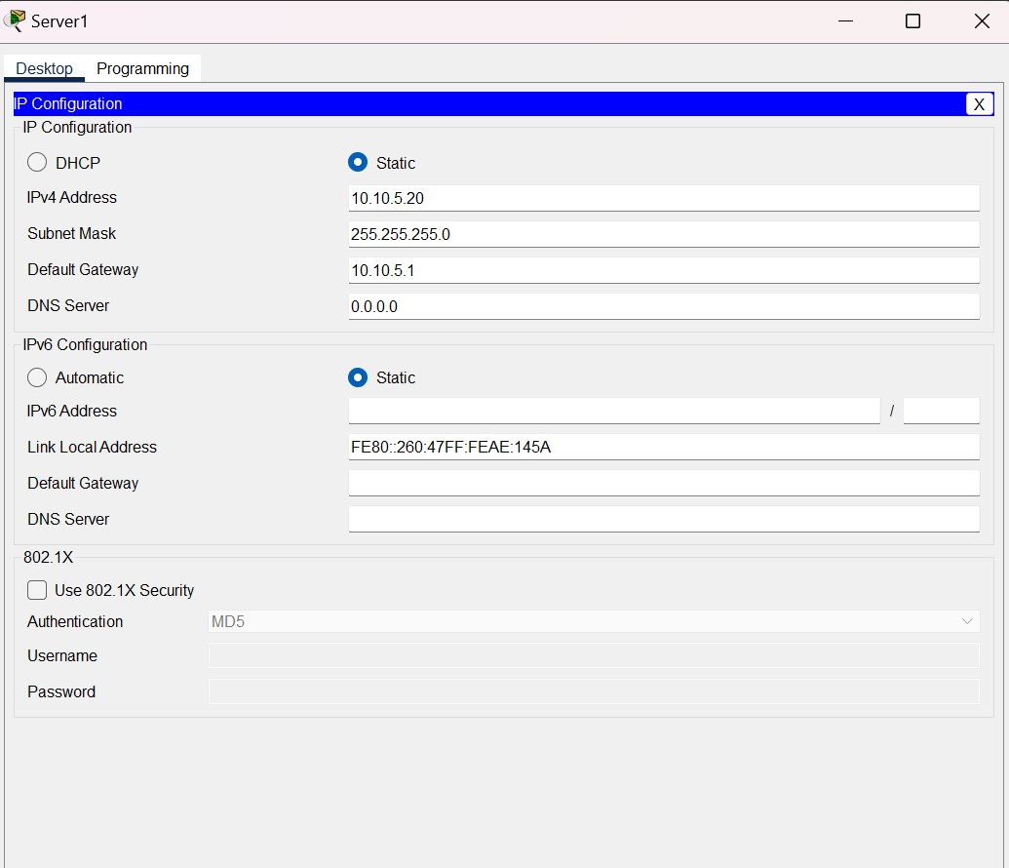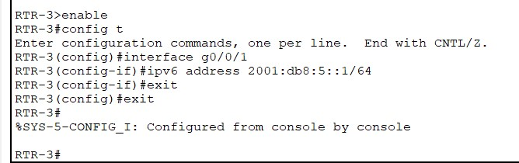

**PART D: Packet Tracer - Use Ping and Traceroute to Test Network Connectivity - Physical Mode**

|  |  |  |  |  |
| --- | --- | --- | --- | --- |
| **Device** | **Interface** | | **IP Address / Prefix** | **Default Gateway** |
| R1  *R1*  *R1*  *R1*  *R1*  *R1* | G0/0/0  *G0/0/0*  *G0/0/0* | | 64.100.0.2 /30 | N/A  *N/A*  *N/A*  *N/A*  *N/A*  *N/A* |
| 2001:db8:acad::2 /64 |
| fe80::2 |
| G0/0/1  *G0/0/1*  *G0/0/1* | | 192.168.1.1 /24 |
| 2001:db8:acad:1::1 /64 |
| fe80::1 |
| ISP  *ISP*  *ISP*  *ISP*  *ISP*  *ISP* | G0/0/0  *G0/0/0*  *G0/0/0* | | 64.100.0.1 /30 | N/A  *N/A*  *N/A*  *N/A*  *N/A*  *N/A* |
| 2001:db8:acad::1 /64 |
| fe80::1 |
| G0/0/1  *G0/0/1*  *G0/0/1* | | 209.165.200.225 /27 |
| 2001:db8:acad:200::225 /64 |
| fe80::225 |
| S1  *S1*  *S1* | VLAN 1  *VLAN 1*  *VLAN 1* | | 192.168.1.2 /24 | 192.168.1.1 |
| 2001:db8:acad:1::2 /64 | fe80::1  *fe80::1* |
| fe80::2 |
| PC-A  *PC-A* | NIC  *NIC* | | 2001:db8:acad:1::10 /64 | fe80::1 |
| 192.168.1.10 /24 | 192.168.1.1 |
| External | NIC | | 209.165.200.226 /27 | 209.165.200.225 |
| **Device** |  | **Interface** | **IP Address / Prefix** | **Default Gateway** |
| *External* | *NIC* |  | 2001:db8:acad:200::226 /64 | fe80::225 |

**Step 1: Test network connectivity to R1 using PC-A.**

From **PC-A**, ping the addresses listed in the following table and record the average round trip time and IPv4 TTL, or IPv6 Hop Limit.

|  |  |  |  |
| --- | --- | --- | --- |
| **Destination** | **Average Round Trip Time (ms)** |  | **TTL / Hop Limit** |
| 192.168.1.10 | 4 | 128*k* |  |
| 2001:db8:acad:1::10 | 2*blank* | 128*k blank* |  |
| 192.168.1.1 (R1) | 0 | 255 |  |
| 2001:db8:acad:1::1 (R1) | *l*0*ank* | 255 |  |
| 192.168.1.2 (S1) | *l*0*ank blank* | 255 *blank* |  |
| 2001:db8:acad:1::2(S1) | 2*lank* | 255 *blank* |  |
| 64.100.0.2 (R1) | *blank l*0*ank* | 255 *blank* |  |
| 2001:db8:acad::2 (R1) | *l*0*ank blank* | 255 *blank* |  |
| 64.100.0.1 (ISP) | *l*0*ank blank* | 254 *blank* |  |
| 2001:db8:acad::1 (ISP) | *l*0*ank blank* | *b*254 *lank* |  |
| 209.165.200.225 (ISP G0/0/1) | Destination host unreachable | Destination host unreachable |  |
| 2001:db8:acad:200::225 (ISP G0/0/1) | Request time out | *blan* Request time out *k* |  |
| **Destination** | **Average Round Trip Time (ms)** |  | **TTL / Hop Limit** |
| 209.165.200.226 (External) | Destination host unreachable *blank* | Destination host unreachable *blank* |  |
| 2001:db8:acad:200::226 (External) | Request time out *blank* | Request time out *blank* |  |

**Step 2: Perform pings from S1 to External.**

From **S1**, attempt to ping **ISP** and **External** using IPv4 and IPv6 addresses.

Question:

What are the ping results from S1 to ISP and External?

The pings were successful to ISP G0/0/0 interface, ISP G0/0/1 interface and External NIC.

**Part 2: Use Tracert and Traceroute Commands for Basic Network Testing**

**Step 1: From PC-A, use the tracert command to External.**

1. At the command prompt of **PC-A**, type **tracert 209.165.200.226**.

1. Repeat the tracert command using the IPv6 address. At the command prompt, enter **tracert 2001:db8:acad:200::226**.

**Step 2: From S1, use the traceroute command to External.**

**Part 3: Correct the network connectivity issue at ISP.**

1. From the terminal of **S1**, SSH into the ISP router using the G0/0/0 interface to correct the problem.

C:\> **ssh -l admin 64.100.0.1**

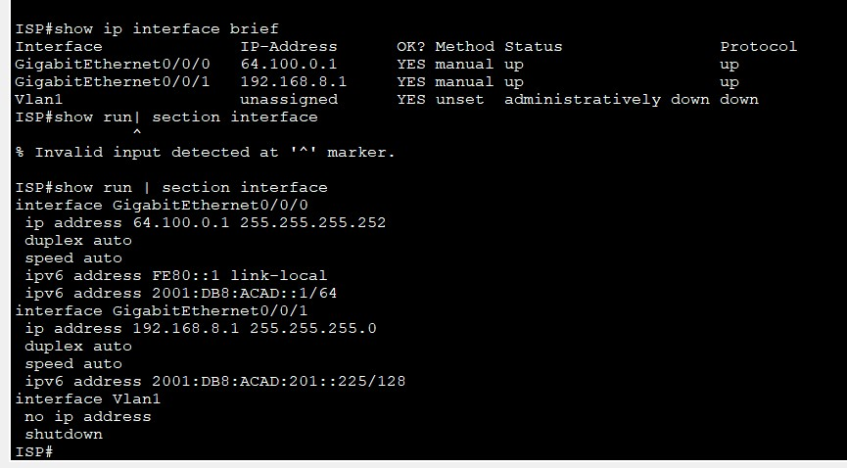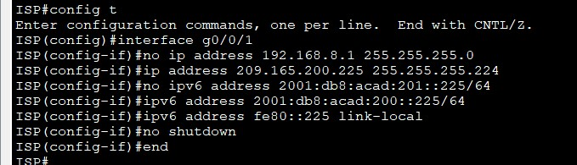

**Step 2: Verify end-to-end connectivity.**

**Use Extended Ping Commands**

**Step 1: Use extended ping commands on PC-A.**

**What is the ICMP error messages did you receive?**

Destination net unreachable, request timed out.

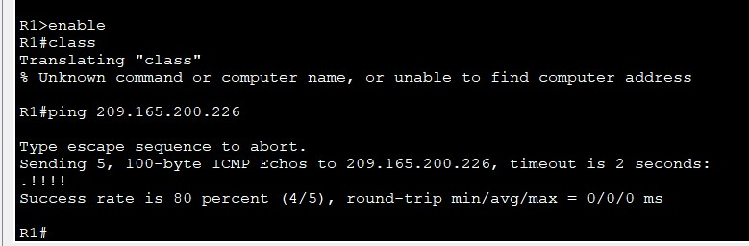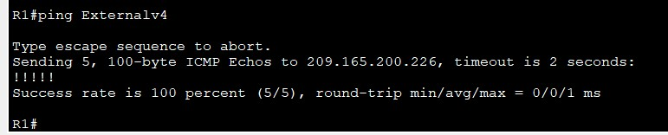

**What is the IP address used?**

209.165.200.226

**Reflection Questions**

1. **What could prevent ping or traceroute responses from reaching the originating device beside network connectivity issues?**

Firewalls and faulty devices.***pe your answers here.***

1. **If you ping a non-existent address on the remote network, such as 209.165.200.227, what is the message displayed by the ping command? What does this mean? If you ping a valid host address and receive this response, what should you check?**

The ping command will display host unreachable message. If the message is received despite having the correct host address, we should check the configuration of the router.

***Type your answers here.***

1. **If you ping an address that does not exist in any network in your topology, such as 192.168.5.3, from a Windows-based PC, what is the message displayed by the ping command? What does this message indicate?**

The request timed out message is displayed by the ping command. This indicates that the ICMP echo request loops throughout the network until its Time to Live (TTL) reaches 0 as the host address does not exist in the network.